Earth and Space Science Study Guide 25-26

Rocks and Minerals
https://scioly.org/wiki/Rocks_and_Minerals
- A general guide on the event from the official Science Olympiad wiki
https://geo.libretexts.org/Bookshelves/Geology/Fundamentals_of_Geology_(Schulte)/03%3A_Rocks_and_the_Rock_Cycle/3.03%3A_The_Rock_Cycle
https://quizlet.com/9109714/science-olympiad-rocks-and-minerals-terms-flash-cards/

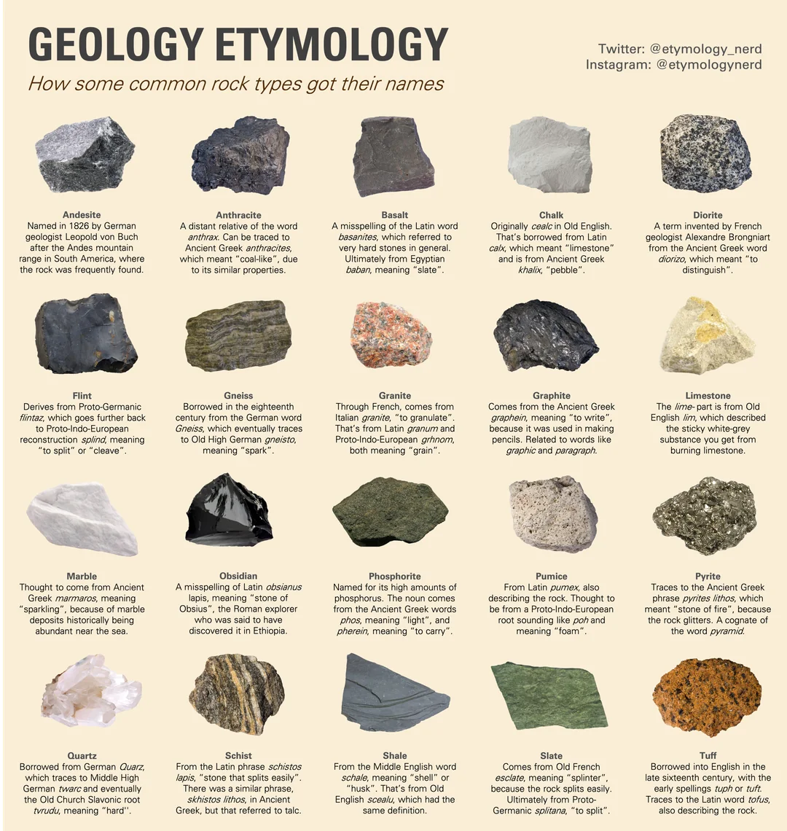

- You don’t need to know how they got their names, but you may be asked to identify some of these common rock types!

Remote Sensing
https://scioly.org/wiki/Remote_Sensing
- General guide from the Science Olympiad Wiki, expect some questions from the “satellite imaging” and “climate change processes” sections
- Know the definitions of composite, contrast, resolution, and Snell’s Law.
https://geo.libretexts.org/Bookshelves/Geography_(Physical)/Remote_Sensing_(Knudby)/01%3A_Chapters/1.04%3A_EMR_interactions_with_the_Earths_atmosphere_and_surface
- Refraction and scattering
https://www.earthdata.nasa.gov/learn/earth-observation-data-basics/remote-sensing
https://www.epa.gov/climatechange-science/basics-climate-change

Astronomy
More Resources/Information:
https://scioly.org/wiki/Astronomy
https://chandra.harvard.edu/edu/olympiad.html
https://quizlet.com/372476735/astronomy-science-olympiad-master-flash-cards/
https://quizlet.com/874781438/science-olympiad-2024-astronomy-flash-cards/
https://scioly.org/forums/viewtopic.php?t=27609
https://www.scribd.com/document/703324483/181414532-SciOly-Astronomy-Reference-Sheet
https://www.soinc.org/astronomy-c

1. Astronomy Basics

Celestial Sphere
- Right Ascension (RA): Like longitude, measured in hours (0–24h).
- Declination (Dec): Like latitude, measured in degrees (+90° = North Celestial Pole, –90° = South Celestial Pole).
- Ecliptic: Path of the Sun across the sky.
- Zenith: Point directly overhead.

Light & Telescopes
- Telescopes:
  - Refractor: Uses lenses (chromatic aberration).
  - Reflector: Uses mirrors (larger sizes possible).
  - Radio: Detects long wavelengths (e.g., pulsars, CMB).
  - Resolution limit: θ ≈ 1.22 λ / D. Bigger aperture = better resolution.

Spectroscopy
- Absorption lines: Cool gas absorbs certain wavelengths.
- Emission lines: Hot gas emits at certain wavelengths.
- Doppler Effect:
  - Radial velocity: v/c = Δλ/λ.
  - Redshift = moving away; blueshift = toward observer.

2. Stellar Evolution

Life Cycle of Stars

- Low-mass stars (<8 M☉): Protostar → Main Sequence → Red Giant → Planetary Nebula → White Dwarf.
- High-mass stars (>8 M☉): Protostar → Main Sequence → Red Supergiant → Supernova → Neutron Star/Black Hole.
- Hertzsprung–Russell Diagram (HRD)
- Axes: Luminosity (y-axis), Temperature (x-axis, decreases to the right).

Main Regions:

- Main Sequence (diagonal band).
- Giants (upper-right).
- White Dwarfs (lower-left).
- Key Idea: Mass determines a star’s fate.

3. Exoplanets

Detection Methods

- Transit Method: Star dims when planet passes in front.
- Transit depth ∝ (Rp/Rs)².
- Radial Velocity (RV): Star wobbles due to planet’s gravity.
- Measured via Doppler shift.
- Direct Imaging: Rare; blocks star’s light.
- Microlensing: Gravity lens temporarily magnifies distant star.

Missions

- Kepler: Found thousands of transiting planets.
- TESS: Ongoing; brighter, closer stars.
- JWST: Can analyze atmospheres with spectroscopy.

Habitability

- Habitable Zone (HZ): Region where liquid water can exist.
- Factors: Distance, stellar type, atmosphere.

4. Cosmology

Big Bang Theory

- Evidence:
  - Cosmic Microwave Background (CMB).
  - Redshift of galaxies.
  - Abundance of H, He, Li.

Hubble’s Law
v = H₀ × d. (v = recessional velocity, d = distance).
Current H₀ ≈ 70 km/s/Mpc.

Dark Matter & Dark Energy

Dark matter: Needed to explain galaxy rotation curves.
Dark energy: Accelerates universe expansion.

Structure

Milky Way: Barred spiral.
Bulge, disk (spiral arms), halo.

5. Spectroscopy & Tools

Blackbody Radiation

- Wien’s Law: λ_max = b/T (b ≈ 2.9×10⁻³ m·K).
- Stefan–Boltzmann Law: L = 4πR²σT⁴.

Stellar Classification

- OBAFGKM (hot → cool).
- Subclasses: 0–9 (e.g., G2 = Sun).

Magnitudes

- Apparent magnitude (m): Brightness seen from Earth.
- Absolute magnitude (M): Brightness at 10 parsecs.
- Distance Modulus: m – M = 5 log(d) – 5.

6. Key Equations

Kepler’s 3rd Law: P² = a³ (if P in years, a in AU, M≈1M☉).

Doppler shift: v/c = Δλ/λ.

Distance Modulus: m – M = 5 log(d) – 5.

Luminosity: L = 4πR²σT⁴.

Wien’s Law: λ_max = b/T.

Dynamic Planet

1. Event Scope & Overview
- This year’s Dynamic Planet theme focuses on physical and geological oceanography, involving tasks that explore the ocean as a physical system. Science OlympiadScience Olympiad
- You’ll likely engage in interpreting diagrams, maps, and data related to ocean phenomena such as waves, currents, densities, and seafloor features.

2. Seawater Properties & Composition
- Salinity, Temperature, Density: These control seawater buoyancy and drive ocean circulation. Science Olympiad
- Dissolved Gases and salts vary with depth, temperature, and location—understanding their distribution is key to many processes. Science Olympiad

3. Energy Inputs & Wave Dynamics
- Learn how solar heating, wind, and Earth's rotation impart energy into the ocean, generating waves and currents. Science Olympiad
- Study wave types—from surface waves to tsunamis—and advanced fluid dynamics like Langmuir circulation. USESO Guide

4. Ocean Circulation & Currents
- Understand surface current systems, including gyres and thermohaline circulation, influenced by wind, Coriolis effect, and density gradients. USESO Guide
- Explore deep water circulation and how salinity and temperature variations drive vertical movement and mixing.

5. Coastal Features & Bathymetry
- Study beaches, shorelines, and features like barrier islands and estuaries to understand land–sea interactions. USESO Guide
- Familiarize yourself with bathymetric mapping techniques and ocean floor topography—understanding seafloor features is often crucial. NC Science OlympiadScience Olympiad

6. Geological Oceanography
- Dive into the geology of the ocean floor: mid-ocean ridges, trenches, abyssal plains, and atolls. Quizlet
- These features tie into plate tectonics and oceanic processes—knowing their formation and location strengthens your understanding.

7. Study & Event Strategies
- Use NOAA resources: including bathymetric data, ocean education modules, and visual tools. NC Science OlympiadScience Olympiad
- Practice with maps, charts, and diagrams—interpreting sea ice extent, currents, and underwater terrain can be pivotal. NC Science OlympiadScience Olympiad
- Work with flashcard sets on Quizlet to reinforce terms like "turbidity current," "abyssal plain," and "atoll." Quizlet+1

Quick Reference Summary Table
Topic | Key Concepts
Seawater Properties | Salinity, temperature, density variation; dissolved substances and their effects
Wave & Energy Dynamics | Wave types (surface, tsunami, etc.), energy inputs from wind and heat
Circulation & Currents | Surface and deep currents, thermohaline circulation, Coriolis effect
Coastal Geography | Shoreline features, beach dynamics, bathymetric structure
Ocean Floor Geology | Ridges, trenches, abyssal plains, atolls; link to tectonics
Visual/Data Interpretation | Bathymetric maps, current diagrams, sea ice extent, density stratification

